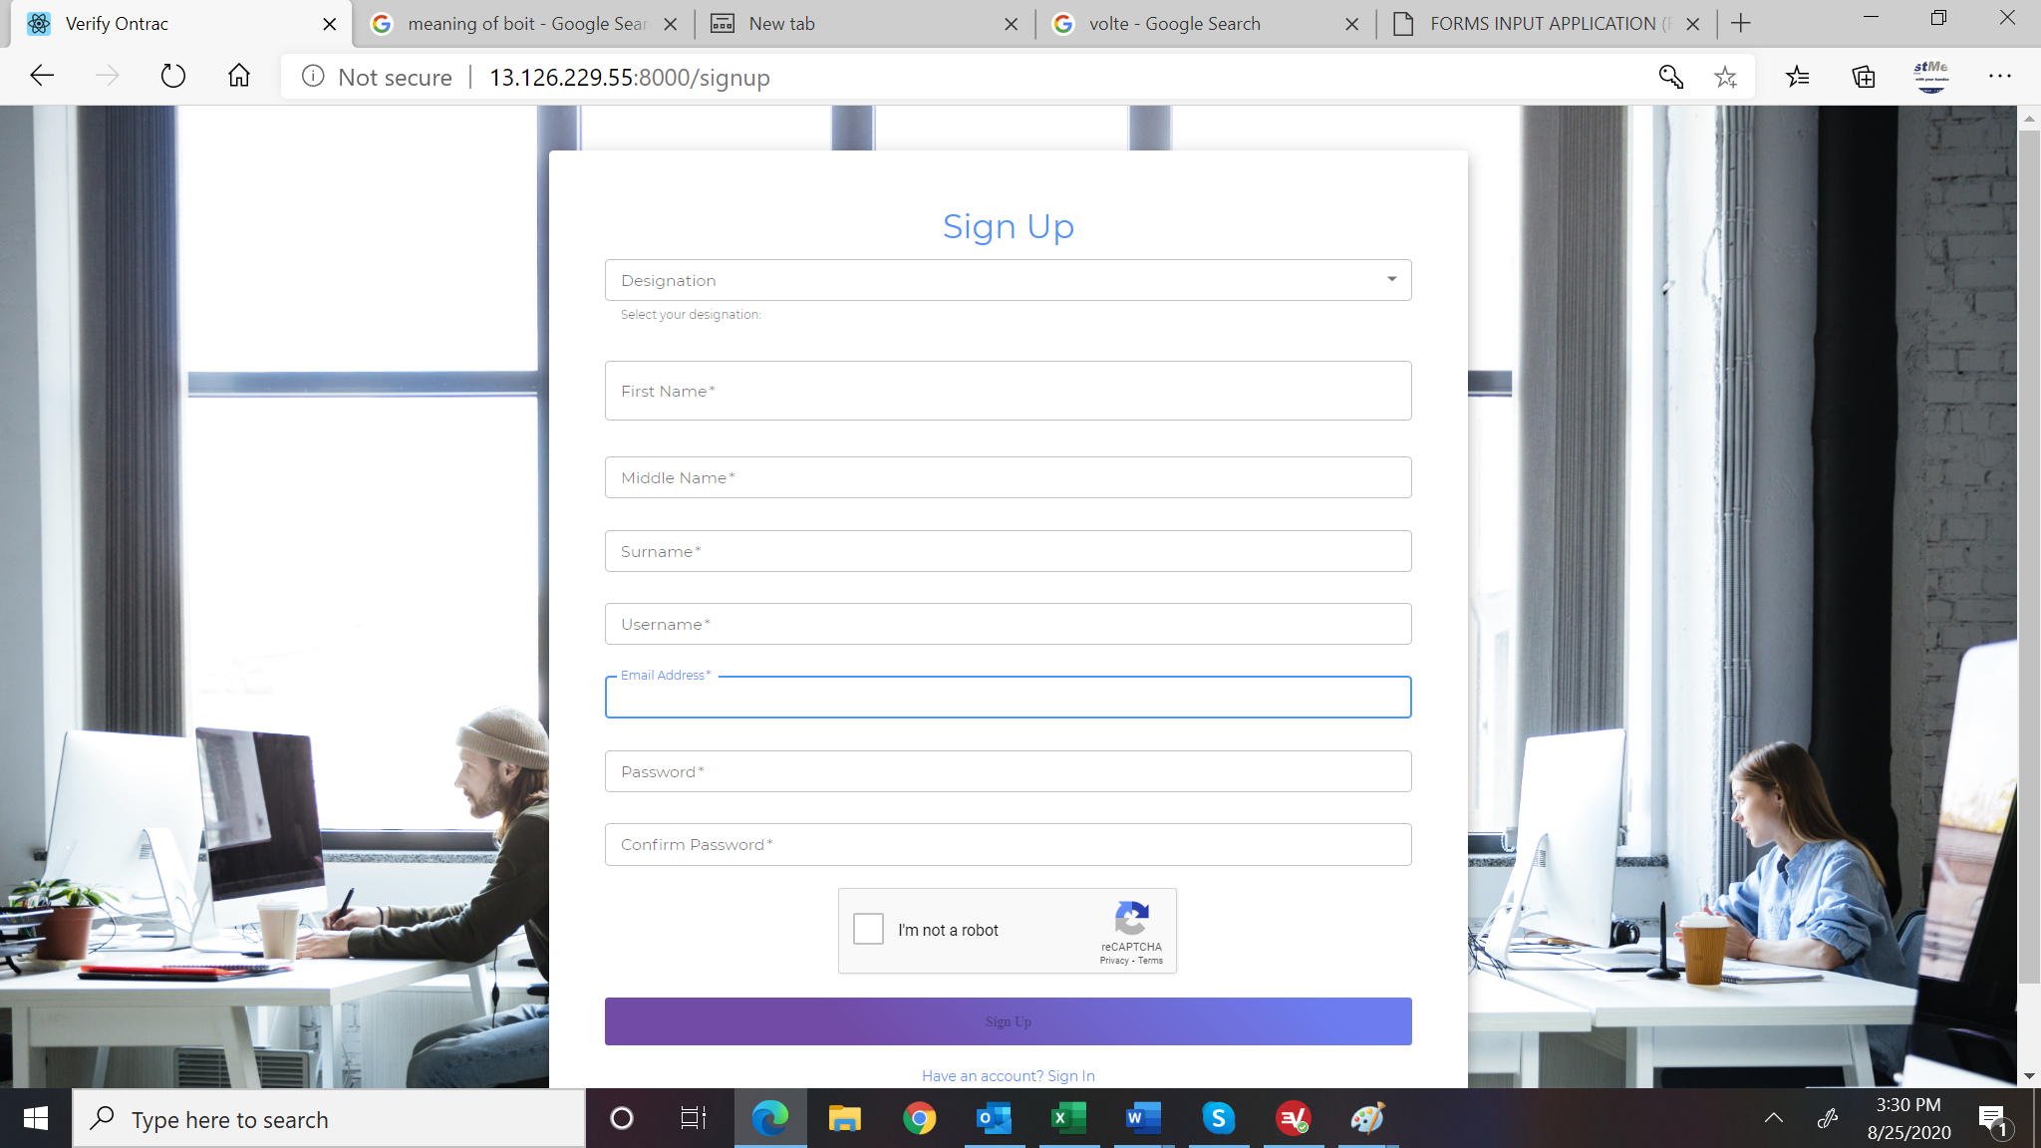

1. Change designation to a radio button Enroll As Employee Enroll As Employer (RC# Required)

[Srikanth]: Completed

1. For Employee, Add Primary Phone #. It should be before the email field. -employee register api(add one field phone)

[Srikanth]: Completed

1. For Employer, include Phone# before email address, Include State after phone number, include Estimated #of Staff <1 to 5, 6 – 15, 16 – 50, Above 50>-dropdown-add the above fileds for register-employer api.

[Srikanth]: Completed

1. Reduce the size of the Sign Up button and use single color instead of color gradient.

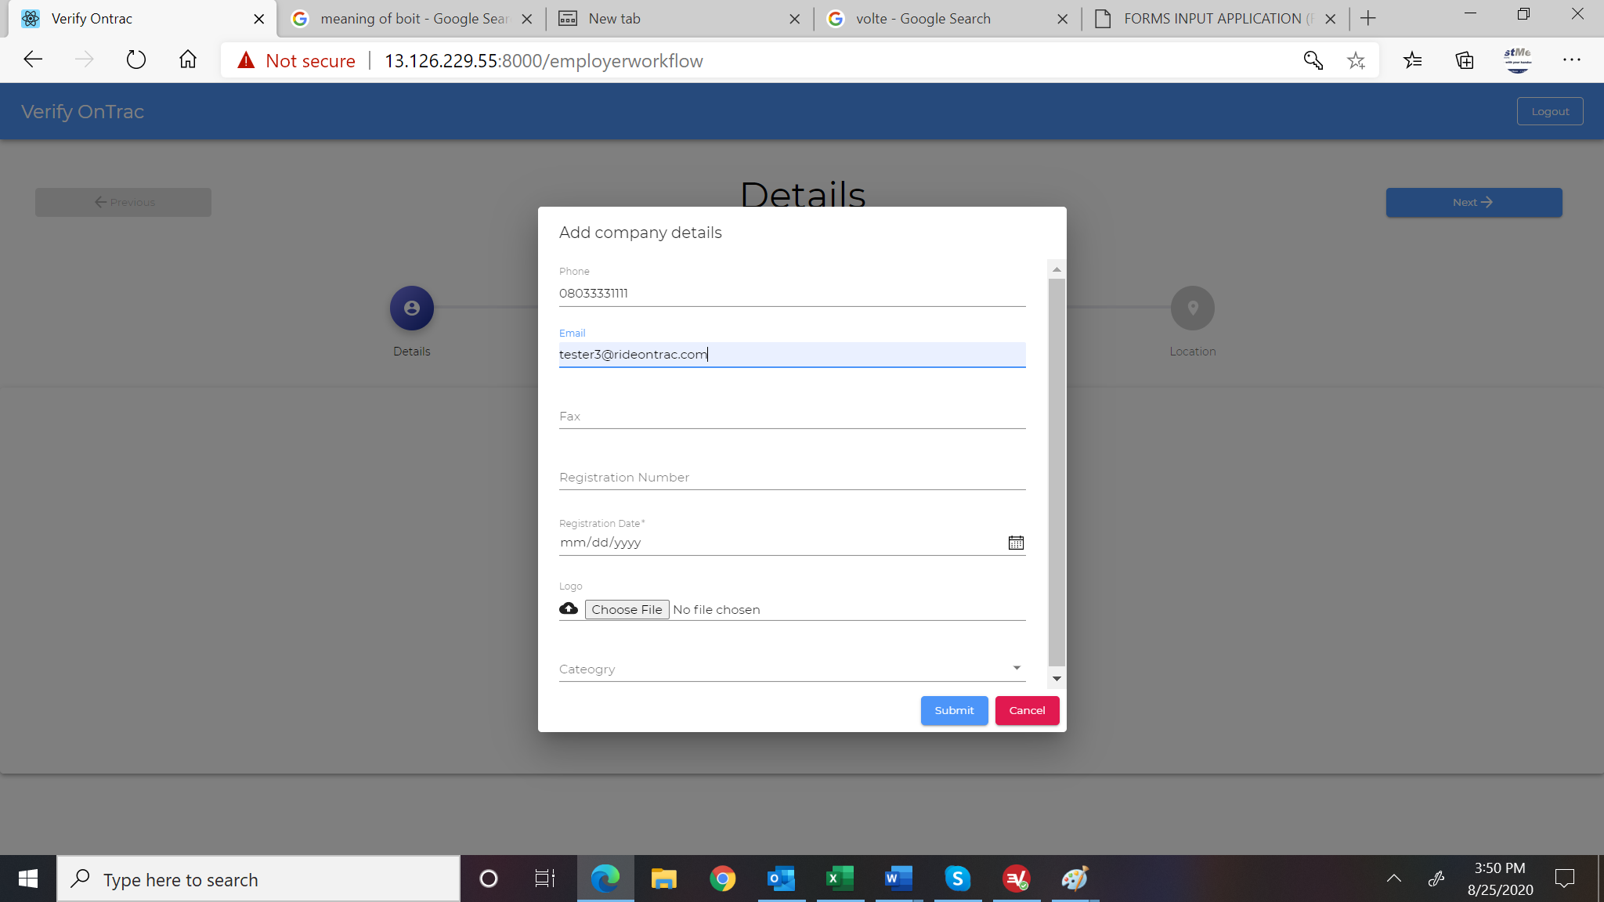

1. Remove fax
2. Change Registration Number to CAC’s RC#

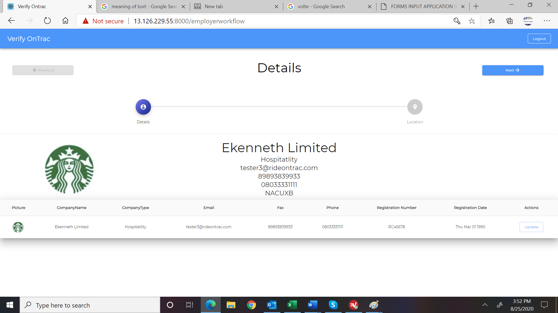

1. Add labels the profile information
   1. Company Name:
   2. Industry: Hospitality
   3. Email Address:
   4. Phone#:
   5. EboIT #:
   6. Subscription valid till: Pending(doubt)

Left alignment and spacing

[Srikanth]:Completed(new field not yet added)

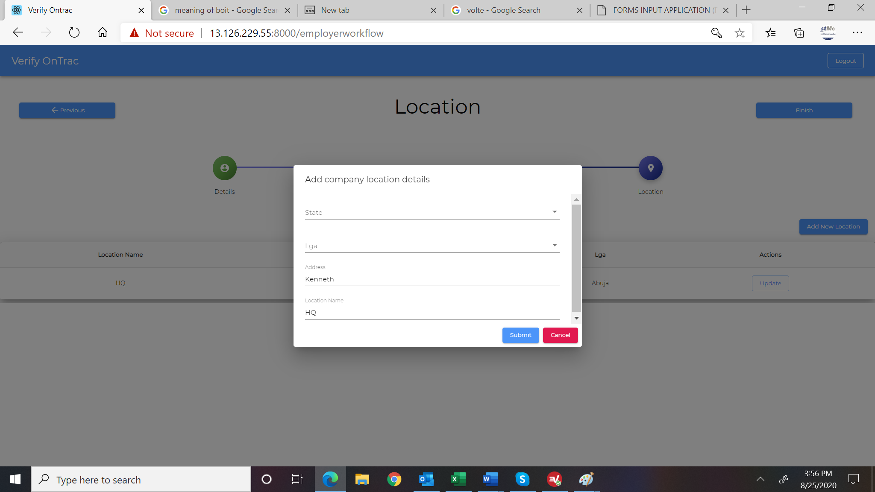

1. Move location name to top before state and rename it Enter Location Name

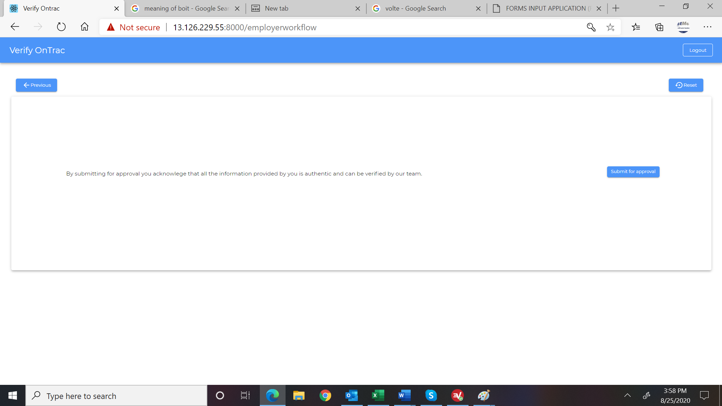

1. Include at the bottom (after the legal text) Checkbox I Agree and a button Cancel (cancel will return user to home page of login)

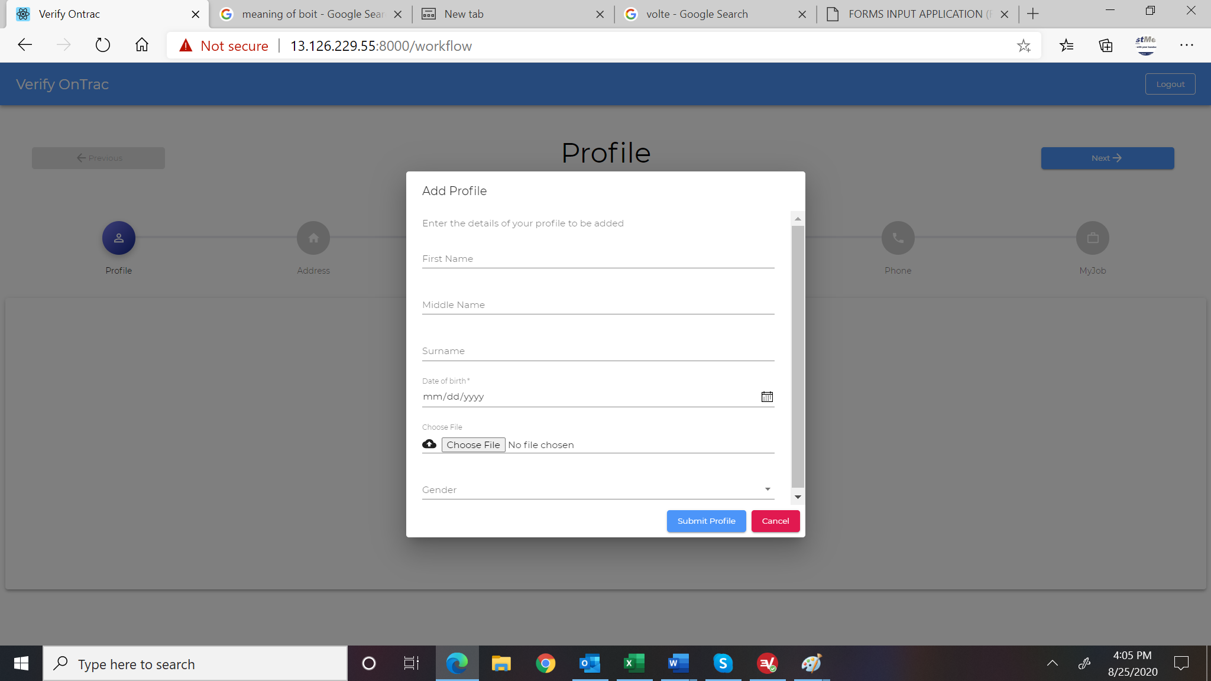

1. Carry over the information from registration form. Employee can then edit and save the information as first profile.-login api is not sending date of birth and gender.

[Srikanth]: Completed

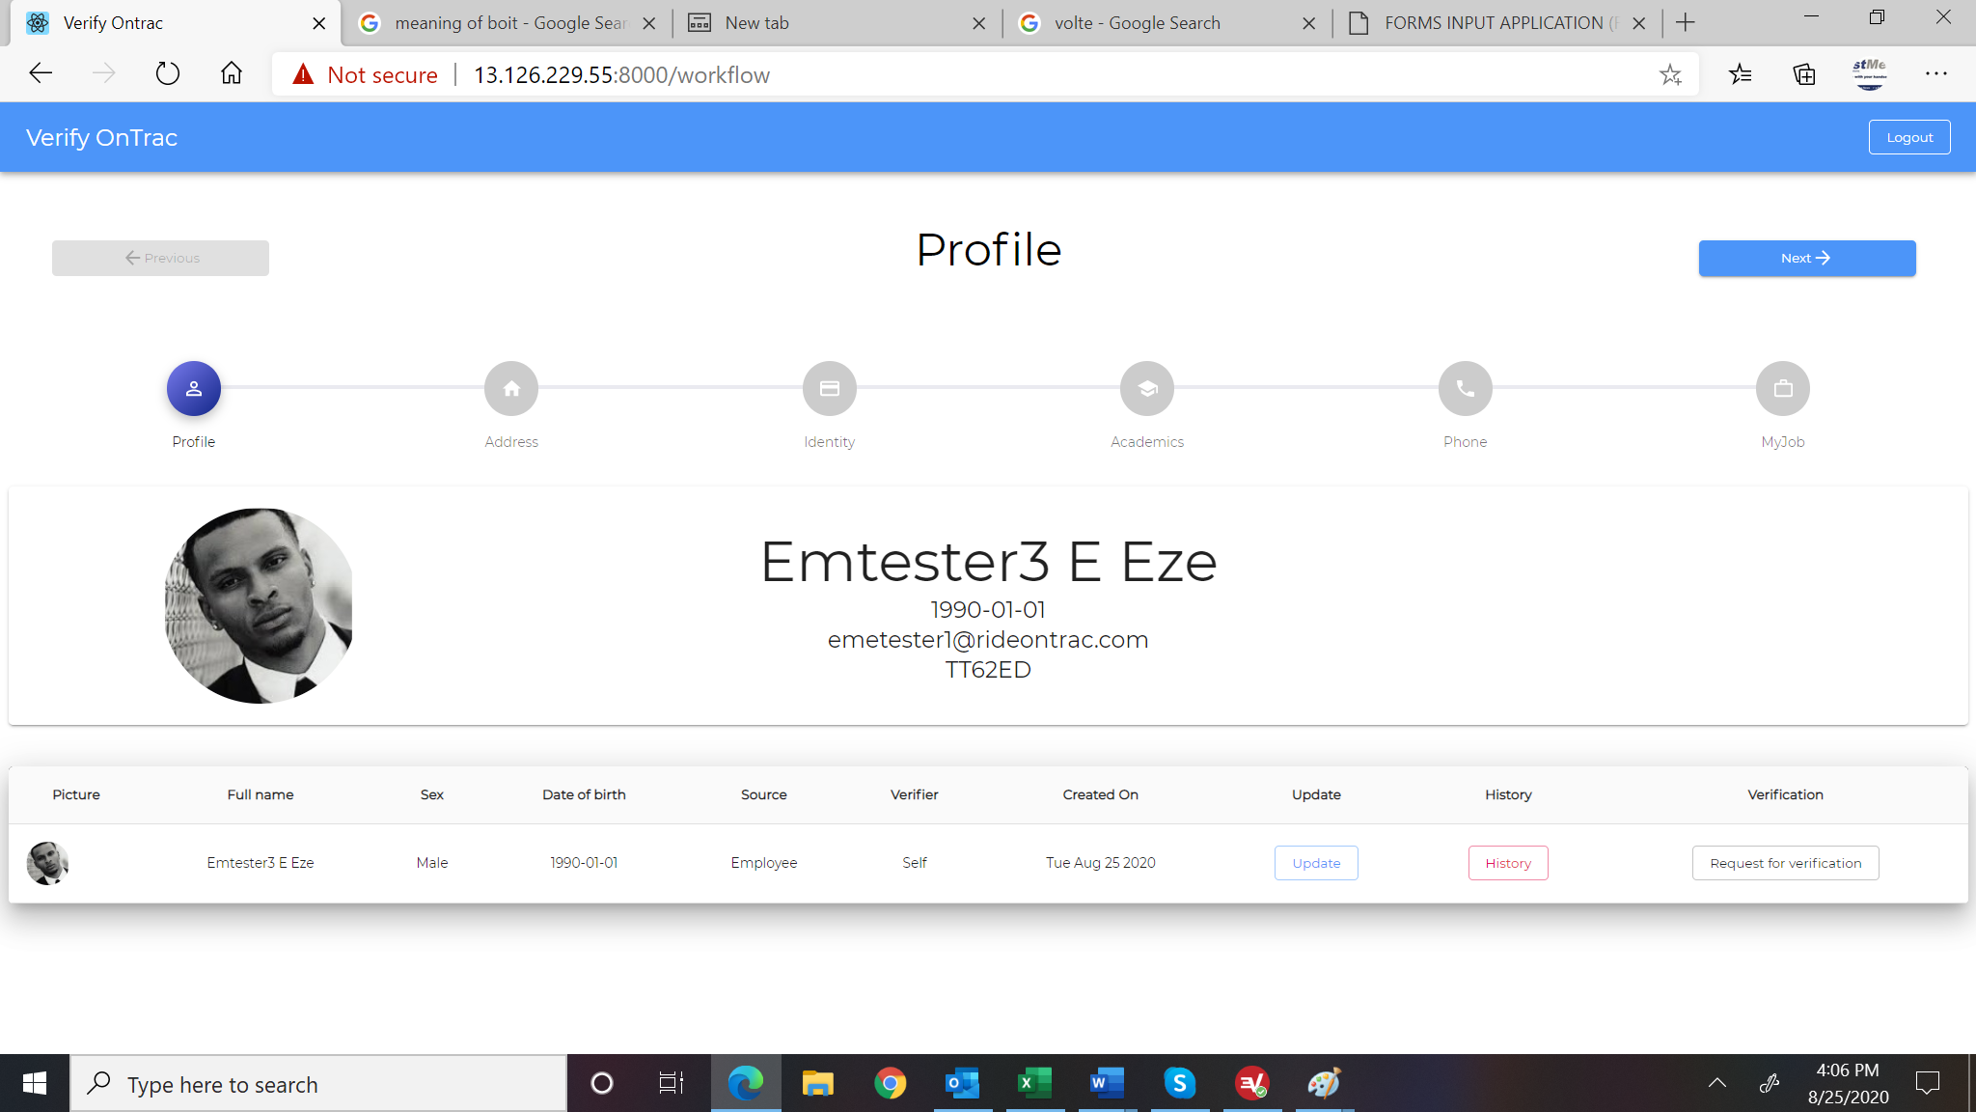

1. Add labels to the information
   1. Name:
   2. DOB:
   3. Email:
   4. Phone#-this field doesn’t exist in this page .

[Srikanth]: Phone exists in the Phone profile and I don’t think needed here

* 1. EboIT #:

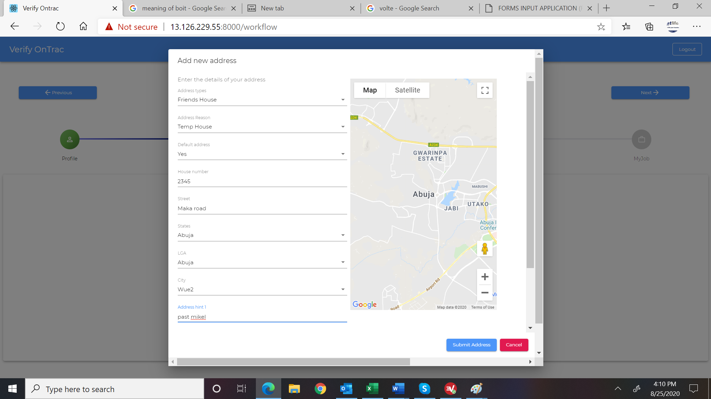

1. We need to allow Others on the city and allow user to type in the city.

[Srikanth]: Exisitng API expects “City” as mandatory field. This has been made optional and you can send “City” from the drop down if available if user selects others, please send “City=NULL” and “city_other” with proper string value.

1. Disable Save Address until information is complete and display a warning of missing information instead of attempting to save and clearing the screen.-formvalidation
2. Unlink the map until we can implement find button since the map implementation is wrong. Add a caption over the map that says “We need to locate this address on the map. Select and click on the map any point you can recognized that is closest to the address.” (doubt)

[Srikanth]: Coordiate1 and Coordiate2 are made optional from the backend.

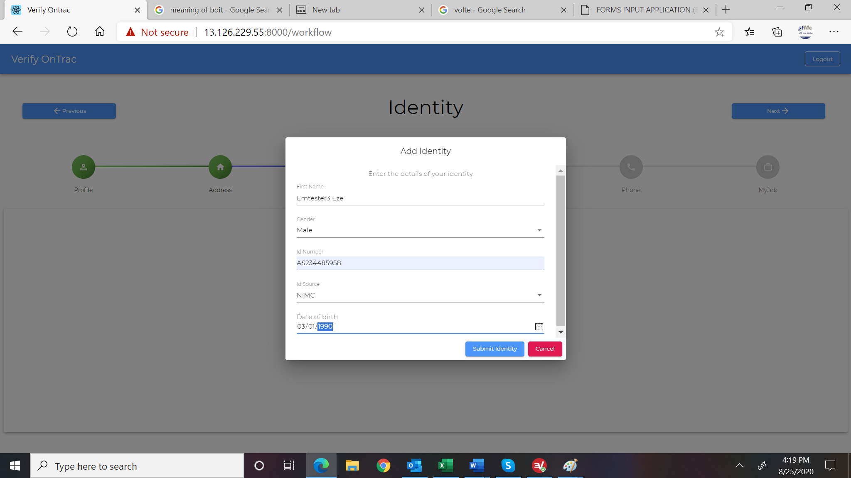

1. Carry information over from registration page.
2. Change first name to “Full Name as it appears on the ID”
3. Change Date of birth to “Date of Birth as it appears on the ID”
4. Add Issue Date and Expiry on Date –these 2 fields are required or optional based on admin configuration(doubt) and requires backend changes add these fields for add new identity api
5. Add Upload Front view and Upload Back view –these 2 fields are required or optional based on admin configuration(doubt) and requires back end changes add these fields for add new identity api.-add frontview and backview buttons

[Srikanth]: added issue date and expiry date in Idenity Create and Update API. Both are mandatory fields

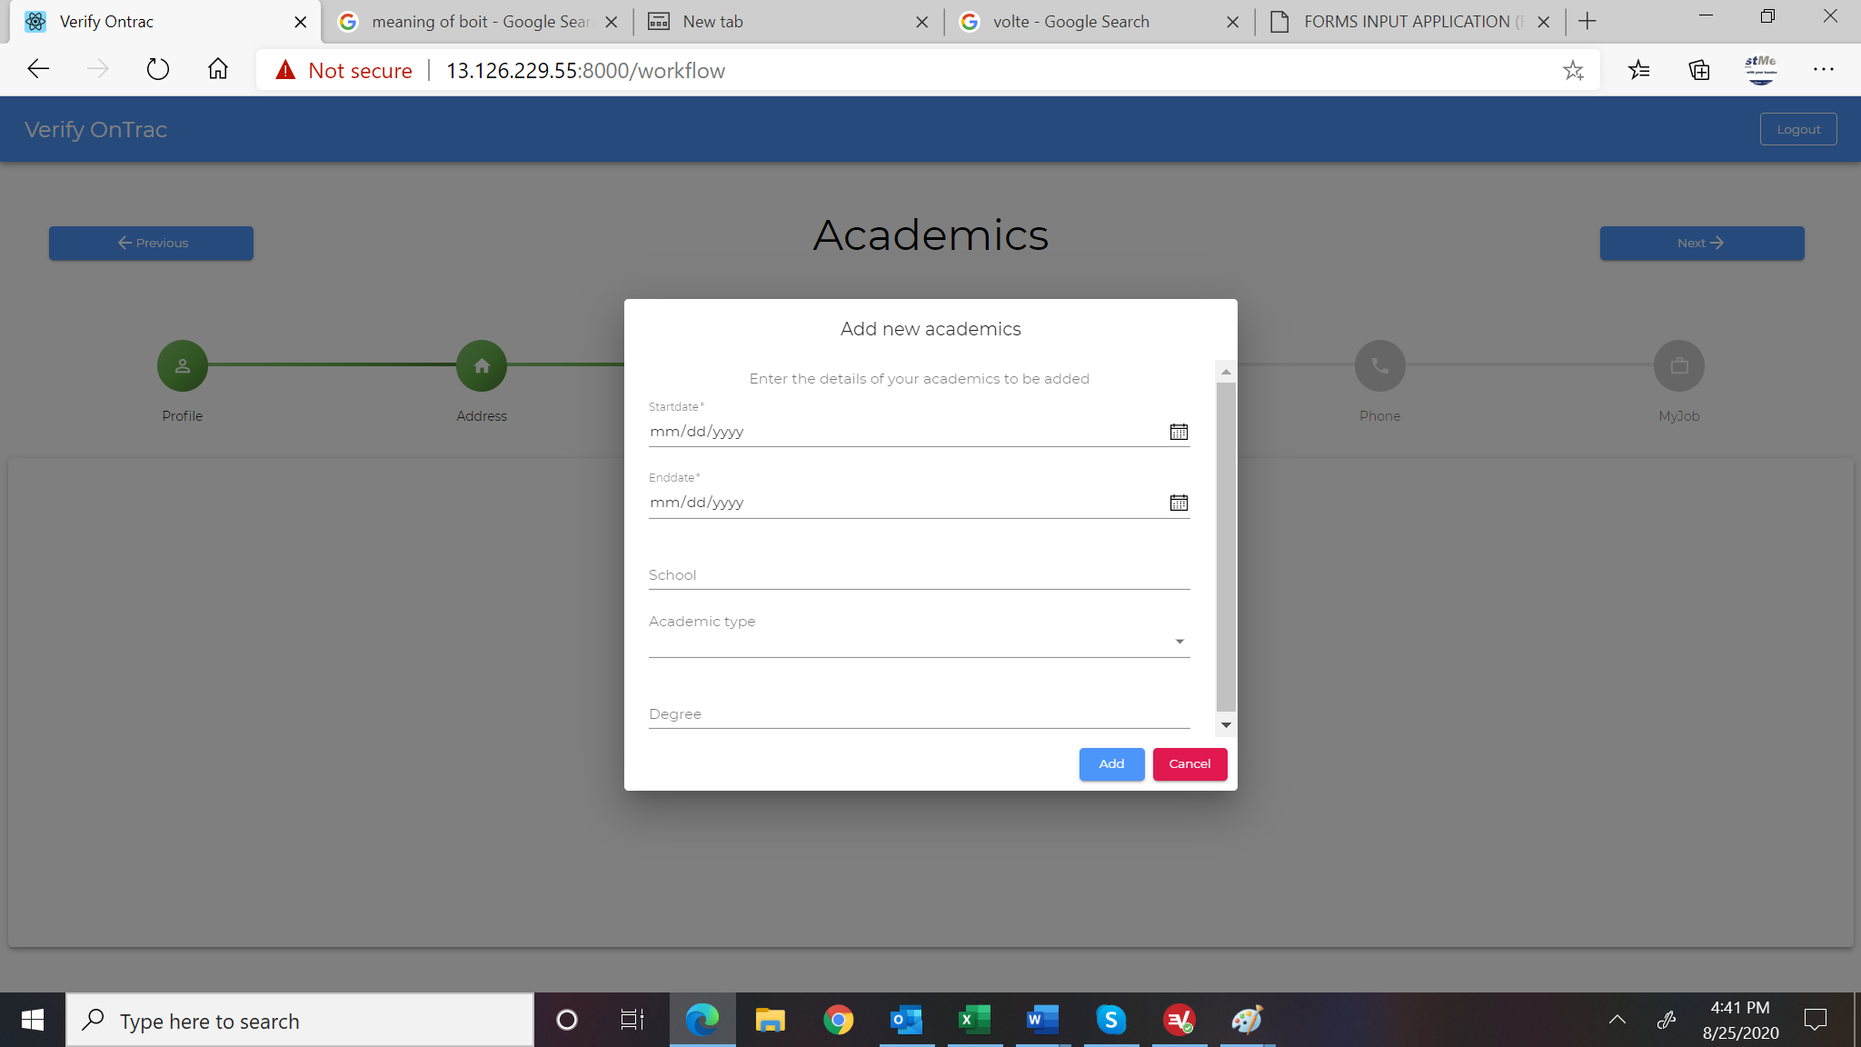

1. Change Startdate and Enddate to Entry Date (MM/YYYY) and Finish Date (MM/YYYY). It is only month an year that is required change the format in these fields for add new academics api and update academics api.

[Srikanth]: No changes needed from backend as backend already accepting the partial date. Please send the partial date as expected by KEN

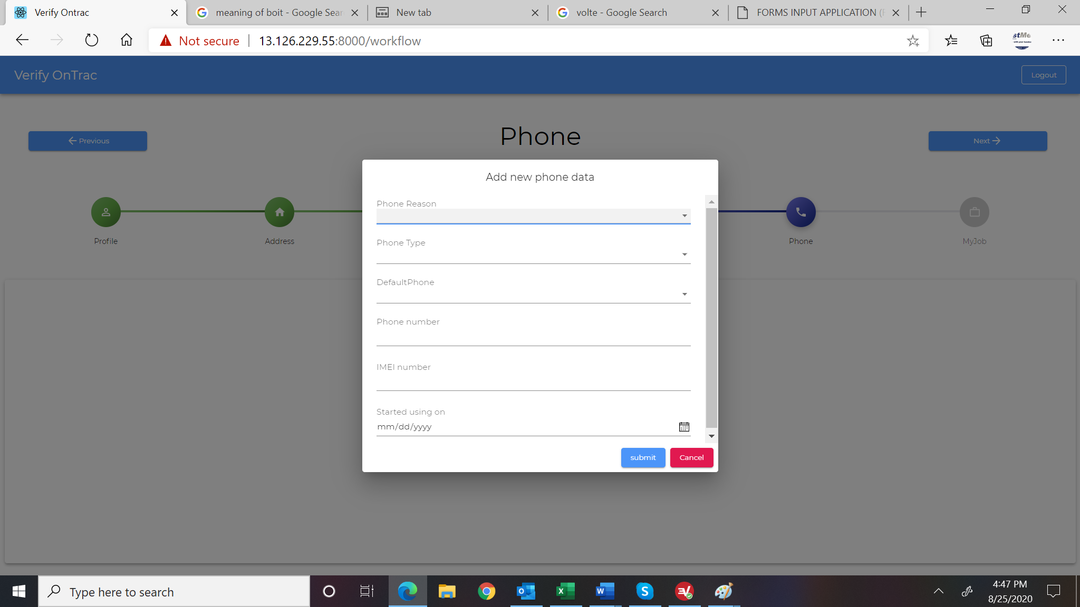

1. Remove IMEI number or make it optional
2. Change start using on to MM/YYYY format-change the in add new phone api and update phone api

[Srikanth]: Modifying this will affect the complete functionality. So I suggest UI can use 01 as the date by default and send to back end. Also while reading the start and end date please ignore the date (01).

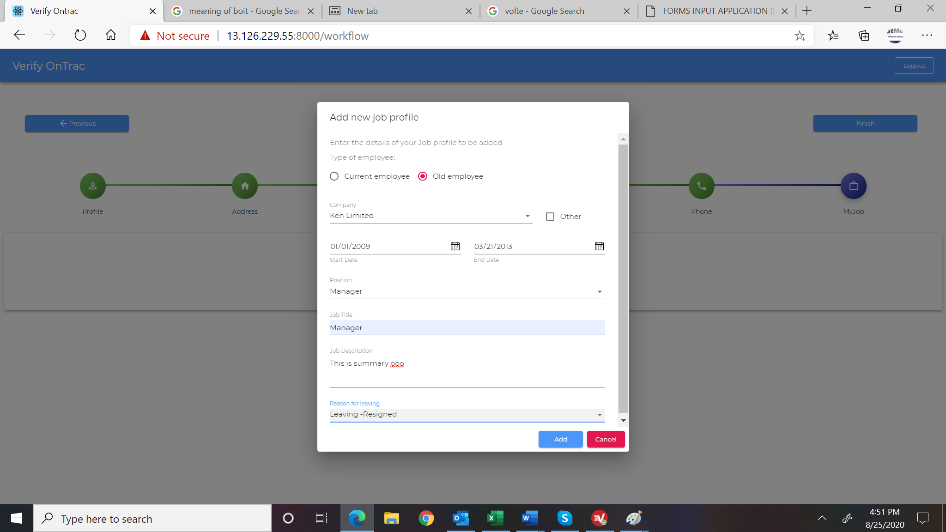

1. Reword Type of Employee to Are you currently at this job. And change Current Employee to Yes and Old Employee to No.
2. Change start date and end date format to MM/YYYY format.(need backend change) change the date format for add jobprofile api

[Srikanth]: Modifying this will affect the complete functionality. So I suggest UI can use 01 as the date by default and send to back end. Also while reading the start and end date please ignore the date (01).

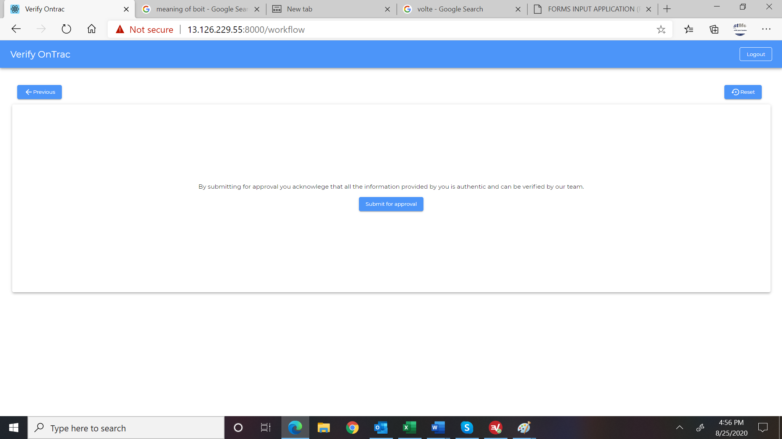

1. Include at the bottom (after the legal text) Checkbox I Agree and a button Cancel (cancel will return user to home page of login)

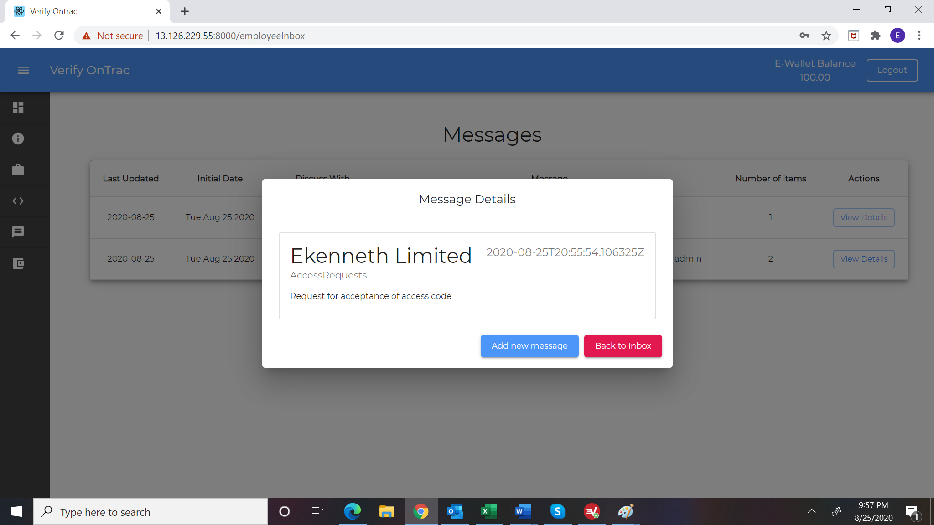

1. Format data for date properly

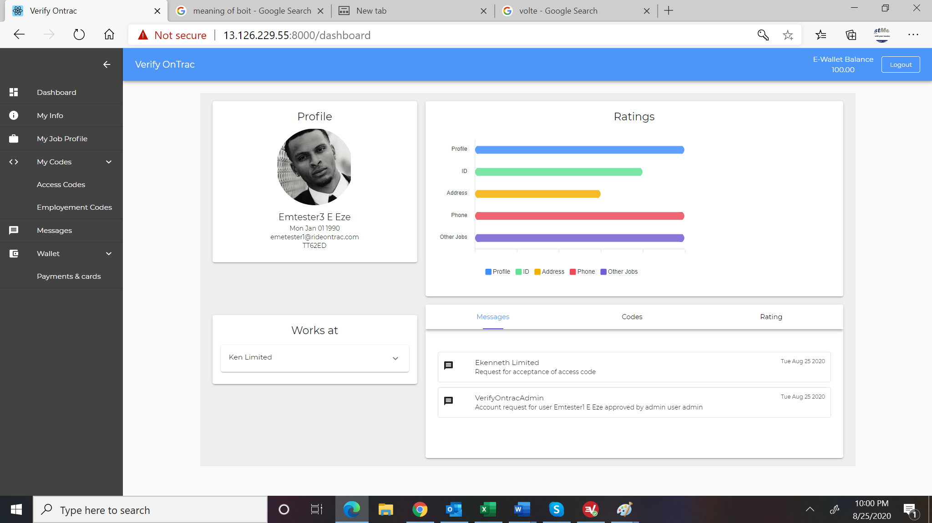

1. Have the main menu open by default and to remain open until the user clicks to closer
2. Remove wallet and make Payments & Cards the menu item

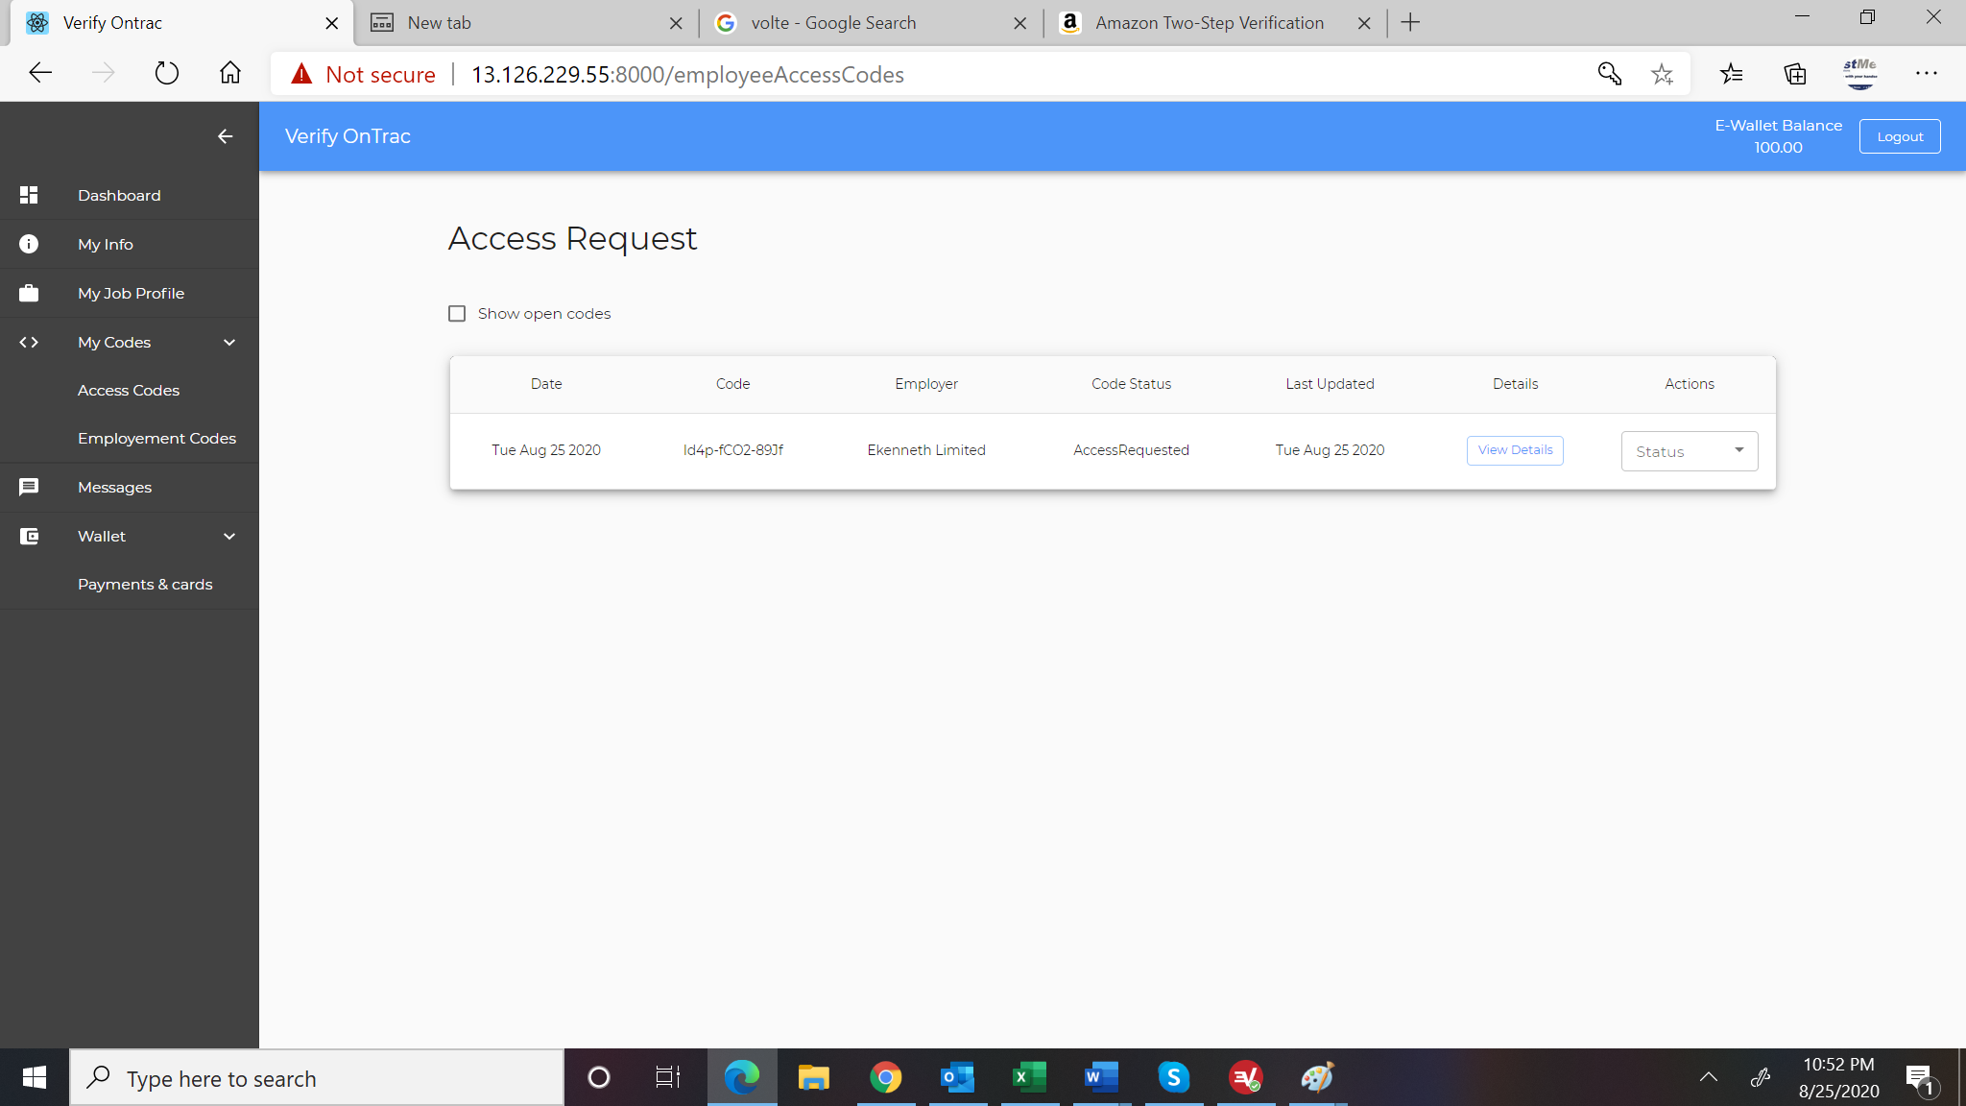

1. Rename My Codes to Code Request on the left menu
2. Remove Access Request and Employment Request from the menu so that clicking on Code Request open the employment codes page and combing Access Request as the first tab. Rename Employment Codes to Employment Request. -comments/////

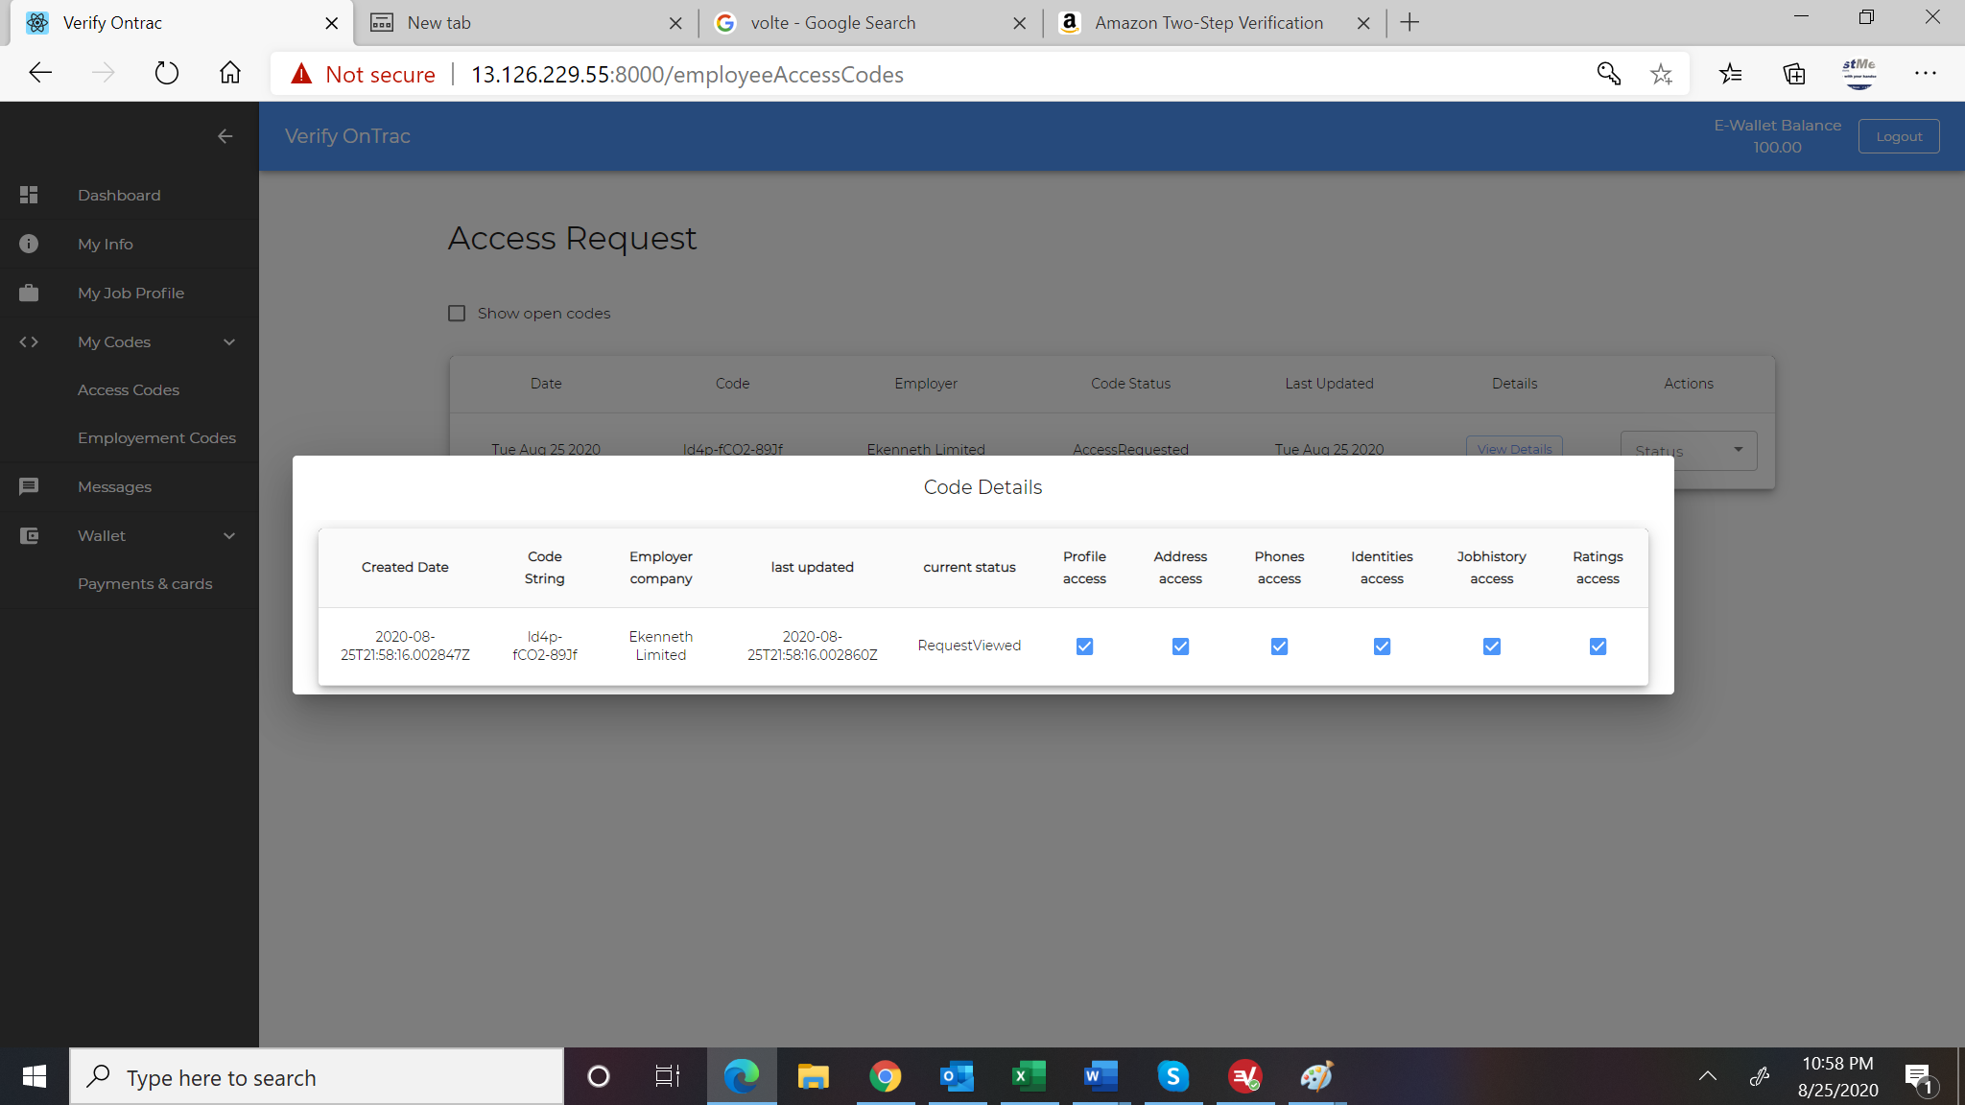

1. Format date properly-not yet completed
2. Change title from Code Details to Following Access Is Requested-
3. Add a close button

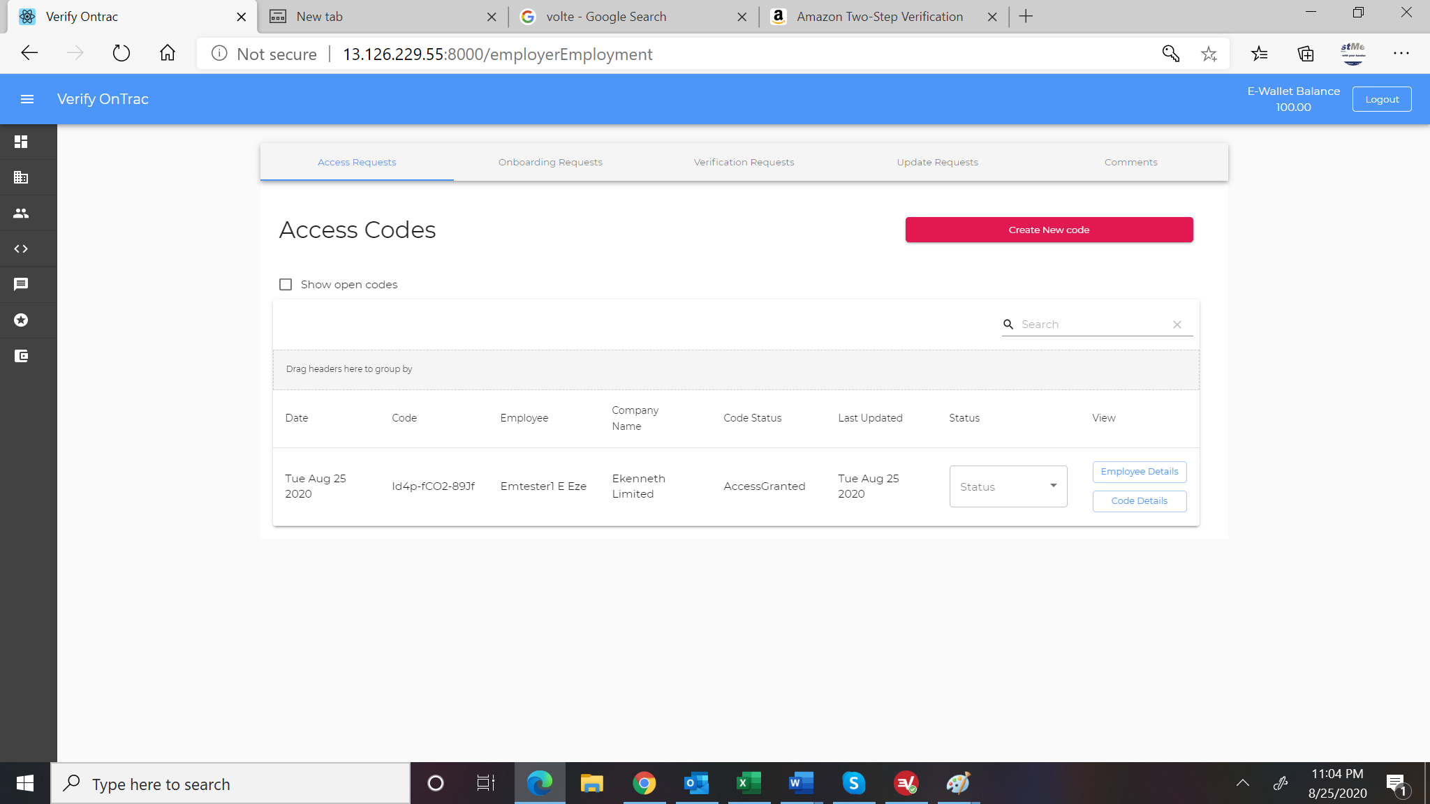

1. Employee details and code details does not work when clicked on. Please check.-check for last name
2. Rename Employee Detail to View Record -view details

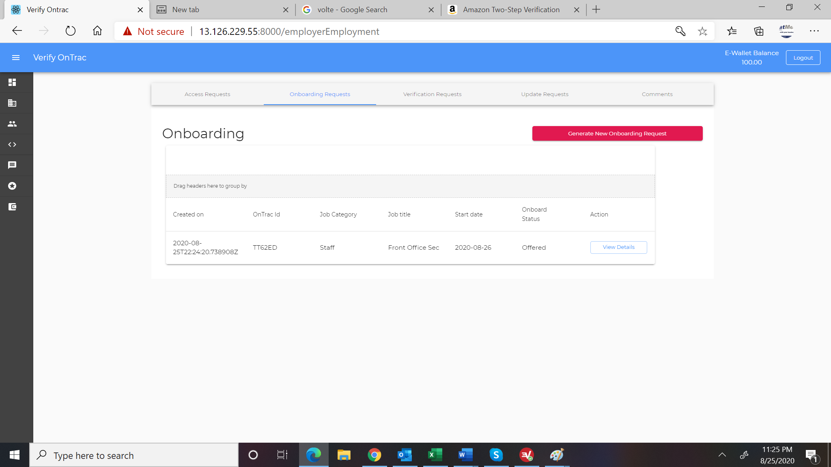

1. Add Staff Name on the list